JUnit Basic Testing Exercises

Name: Shubham Bej

Aim
To understand the fundamentals of unit testing using JUnit 4, create a Maven-based Java project, write unit test cases, use different JUnit assertions, and implement the Arrange-Act-Assert (AAA) testing pattern with setup and teardown methods.

Objectives
- To set up a Maven project with JUnit.
- To write basic unit test cases.
- To understand different JUnit assertions.
- To learn the Arrange-Act-Assert (AAA) testing pattern.
- To implement setup and teardown methods using @Before and @After.

Software Requirements
- IntelliJ IDEA Community Edition
- Java JDK 21
- Maven
- JUnit 4.13.2
- Git
- GitHub

Theory
JUnit is an open-source testing framework used for writing and executing unit tests in Java applications. It helps developers verify that individual methods or classes behave as expected.

Features of JUnit
- Simple annotations for writing tests.
- Automated execution of test cases.
- Supports assertions to validate outputs.
- Integrates with Maven and Gradle.
- Provides setup and teardown methods.
- Generates test execution results.

Exercises Performed

Exercise 1 – Setting Up JUnit

Description
A Maven project was created in IntelliJ IDEA. The JUnit dependency (JUnit 4.13.2) was added to the pom.xml file, and Maven successfully downloaded the required libraries.

Outcome
The project was configured successfully, and JUnit libraries were available under External Libraries.
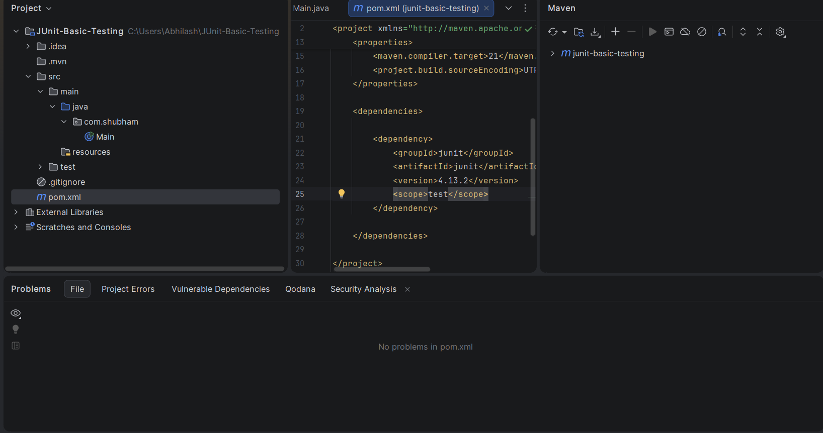

Exercise 2 – Writing Basic JUnit Tests

Description
A Calculator class was created containing four methods:
- Addition
- Subtraction
- Multiplication
- Division
A separate CalculatorTest class was written to test each method using JUnit test cases.

Methods Tested
- add()
- subtract()
- multiply()
- divide()

Outcome
All four test cases passed successfully.
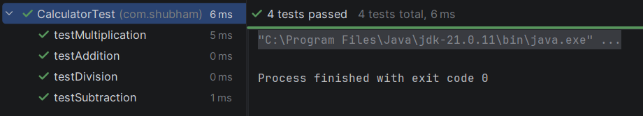

Exercise 3 – Assertions in JUnit

Description
Different JUnit assertions were implemented to verify expected outcomes.

Assertions Used
- assertEquals()
- assertTrue()
- assertFalse()
- assertNull()
- assertNotNull()

Outcome
All assertions executed successfully without errors.
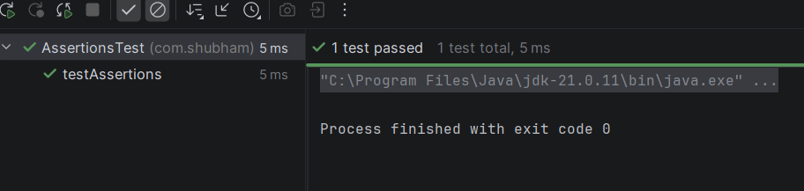

Exercise 4 – Arrange–Act–Assert (AAA) Pattern

Description
The Arrange–Act–Assert testing pattern was implemented.
- Arrange: Initialize required objects and input values.
- Act: Execute the method being tested.
- Assert: Verify the expected output.
The setup and cleanup methods were implemented using:
- @Before
- @After

Outcome
The test executed successfully while demonstrating proper setup and teardown procedures.
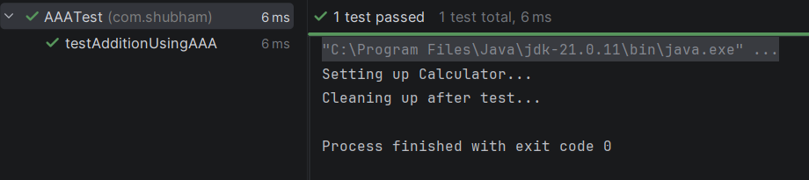

Project Structure

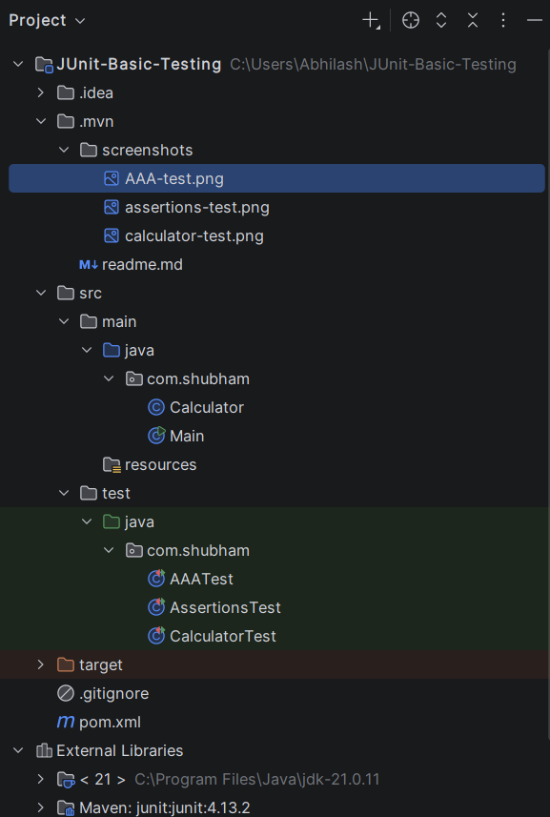

Results
The following tasks were completed successfully:
- Maven project creation
- JUnit dependency configuration
- Writing unit test cases
- Using JUnit assertions
- Implementing the AAA testing pattern
- Executing all test cases successfully

Conclusion
The experiment successfully demonstrated the basics of JUnit testing in Java. A Maven-based project was created, unit test cases were implemented using JUnit 4, different assertion methods were explored, and the Arrange–Act–Assert pattern was applied using setup and teardown methods. All test cases passed successfully, confirming the correctness of the implementation.

References
- JUnit 4 Documentation – https://junit.org/junit4/
- Apache Maven Documentation – https://maven.apache.org/
- Oracle Java Documentation – https://docs.oracle.com/en/java/

Codes that are used:-

pom.xml:
<?xml version="1.0" encoding="UTF-8"?>
<project xmlns="http://maven.apache.org/POM/4.0.0"
xmlns:xsi="http://www.w3.org/2001/XMLSchema-instance"
xsi:schemaLocation="http://maven.apache.org/POM/4.0.0
http://maven.apache.org/xsd/maven-4.0.0.xsd">
<modelVersion>4.0.0</modelVersion>
<groupId>com.shubham</groupId>
<artifactId>junit-basic-testing</artifactId>
<version>1.0-SNAPSHOT</version>
<properties>
<maven.compiler.source>21</maven.compiler.source>
<maven.compiler.target>21</maven.compiler.target>
<project.build.sourceEncoding>UTF-8</project.build.sourceEncoding>
</properties>
<dependencies>
<dependency>
<groupId>junit</groupId>
<artifactId>junit</artifactId>
<version>4.13.2</version>
<scope>test</scope>
</dependency>
</dependencies>
</project>

Calculator.java
package com.shubham;
public class Calculator {
public int add(int a, int b) {
return a + b;
}
public int subtract(int a, int b) {
return a - b;
}
public int multiply(int a, int b) {
return a * b;
}
public int divide(int a, int b) {
return a / b;
}
}

CalculatorTest.java
package com.shubham;
import org.junit.Test;
import static org.junit.Assert.*;
public class CalculatorTest {
Calculator calculator = new Calculator();
@Test
public void testAddition() {
assertEquals(7, calculator.add(3,4));
}
@Test
public void testSubtraction() {
assertEquals(2, calculator.subtract(5,3));
}
@Test
public void testMultiplication() {
assertEquals(15, calculator.multiply(3,5));
}
@Test
public void testDivision() {
assertEquals(2, calculator.divide(10,5));
}
}

AssertionsTest.java:
package com.shubham;
import org.junit.Test;
import static org.junit.Assert.*;
public class AssertionsTest {
@Test
public void testAssertions() {
// Assert Equals
assertEquals(5, 2 + 3);
// Assert True
assertTrue(10 > 5);
// Assert False
assertFalse(2 > 5);
// Assert Null
assertNull(null);
// Assert Not Null
assertNotNull(new Object());
}
}

AAATest.java:
package com.shubham;
import org.junit.After;
import org.junit.Before;
import org.junit.Test;
import static org.junit.Assert.assertEquals;
public class AAATest {
private Calculator calculator;
@Before
public void setUp() {
calculator = new Calculator();
System.out.println("Setting up Calculator...");
}
@After
public void tearDown() {
System.out.println("Cleaning up after test...");
}
@Test
public void testAdditionUsingAAA() {
// Arrange
int a = 10;
int b = 20;
// Act
int result = calculator.add(a, b);
// Assert
assertEquals(30, result);
}
}

